Elton, Gruber, Brown, and Goetzmann
Modern Portfolio Theory and Investment Analysis, 9th Edition
Solutions to Text Problems: Chapter 13

Chapter 13: Problem 1

The equation for the security market line is:

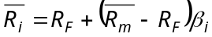

Thus, from the data in the problem we have:

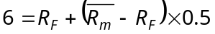 for asset 1

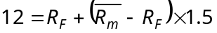 for asset 2

Solving the above two equations simultaneously, we find R_{F} = 3% and 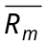 = 9%. Using those values, an asset with a beta of 2 would have an expected return of:

3 + (9 − 3) × 2 = 15%

Chapter 13: Problem 2

Given the security market line in this problem, for the two stocks to be fairly priced their expected returns must be:

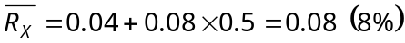

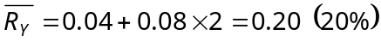

If the expected return on either stock is higher than its return given above, the stock is a good buy.

Chapter 13: Problem 3

Given the security market line in this problem, the two funds’ expected returns would be:

Comparing the above returns to the funds’ actual returns, we see that both funds performed poorly, since their actual returns were below those expected given their beta risk.

Chapter 13: Problem 4

Given the security market line in this problem, the riskless rate equals 0.04 (4%), the intercept of the line, and the excess return of the market above the riskless rate (also called the “market risk premium”) equals 0.10 (10%), the slope of the line. (The return on the market portfolio must therefore be 0.04 + 0.10 = 0.14, or 14%.)

Chapter 13: Problem 5

The price form of the CAPM’s security market line equation is:

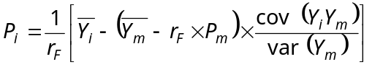

where 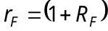 and 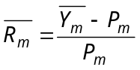.

From Problem 4, we have 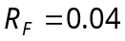 and 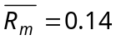. Therefore 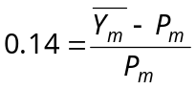 which gives 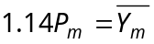.

Substituting these vales into the above security market line equation, we have:

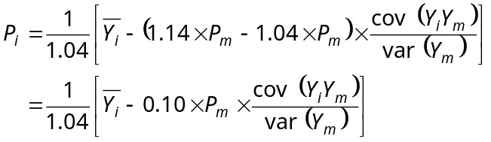

Chapter 13: Problem 6

To be rigorous, one should use the four Kuhn-Tucker conditions shown in Appendix E of Chapter 6. To find the optimum portfolio when short sales are not allowed, we have, for each asset i, the following Kuhn-Tucker conditions:

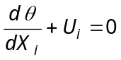 (1)

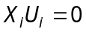 (2)

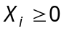 (3)

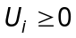 (4)

We have already seen that, given the assumptions of the standard CAPM, setting 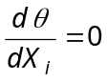 gives the equilibrium first order condition for asset i, which is the standard CAPM’s security market line:

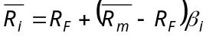
or equivalently

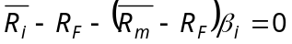

When short sales are not allowed, Kuhn-Tucker condition (1) implies that:

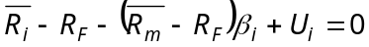

But, since all assets are held long in the market portfolio, X_{i} > 0 for each asset and therefore, given Kuhn-Tucker condition (2), U_{i} = 0 for each asset. Thus, the standard CAPM holds even if short sales are not allowed.

Chapter 13: Problem 7

Using the two assets in Problem 1, a portfolio with a beta of 1.2 can be constructed as follows:

0.5X₁ + (1.5)(1 – X₁) = 1.2

X₁ = 0.3; X₂ = 0.7

The return on this combination would be:

0.3(6%) + 0.7(12%) = 10.2%

Asset 3 has a higher expected return than the portfolio of assets 1 and 2, even though asset 1 and the portfolio have the same beta. Thus, buying asset 3 and financing it by shorting the portfolio would produce a positive (arbitrage) return of 15% − 10.2% = 4.8% with zero net investment and zero beta risk.

Chapter 13: Problem 8

The security market line is:

Substituting the given values for assets 1 and 2 gives two equations with two unknowns:

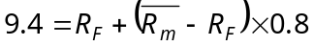

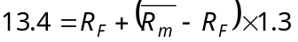

Solving simultaneously gives:

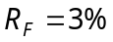; 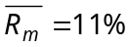

Chapter 13: Problem 9

Substituting the given betas in the given equation yields:

 